（Times New Roman 14pt）OES29-□□□

Please write an English title down here (Times New Roman 14pt, Bold)

|  |  |
| --- | --- |
| (Authors | Affiliation (Times New Roman 10pt)) |
| Manabu ZOSEN | Department of Naval Architecture, Tranomon University  (E-mail address of a representative of authors) E-mail: Zosen-manabu@abcd.efg.hij |
| Jiro MITAKA | Senpaku University |
| Yuho ROPPONGI | Oceanographic Institute |

**Abstract (Times New Roman 9pt Bold)**

Please write your abstract (approx. 100 to 200 words) down here. The space area on the right and left of the abstract should be taken to 4 cm from each edge of the paper, respectively. (Times New Roman 9pt)

# 1. HEADING (Arial 10pt, bold)

Text (Times New Roman 10pt)

Text page should make two columns each of which consists of about 60 lines except a page. The paper must be made ***from 2 pages to 8 pages***.

Figures with full color are no problem because the proceedings will be published using CD-ROM.

## 1.1 Write Subheading (Arial 10pt, Bold)

Text (Times New Roman 10pt)

Equations should be written as follows,  
 , (1)  
 . (2)

(1) Sub-subheading (Times New Roman, Bold 10pt)

Text (Times New Roman 10pt)

This paper describes instructions of the full paper of English version for the 22nd Ocean Engineering Symposium.

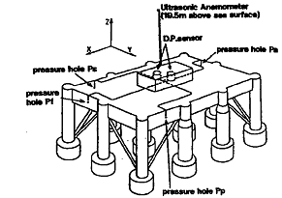

Fig. 16 Measurement of wind pressures  
(Times New Roman 10pt)

# REFERENCES (Arial 10pt, bold)

1. Kim, M.H., Yue, D.K.P., “Slowly varying wave drift force in short crested irregular seas,” Applied Ocean Research, Vol. 11, No. l, pp. 60-65, 1989. (Times New Roman 10pt)
2. Kim, M.H., Yue, D.K.P., “Slowly varying wave drift force in short crested irregular seas,” Applied Ocean Research, Vol. 11, No. l, pp. 60-65, 1989.